# DATA VISUALIZATION

* data/search.json

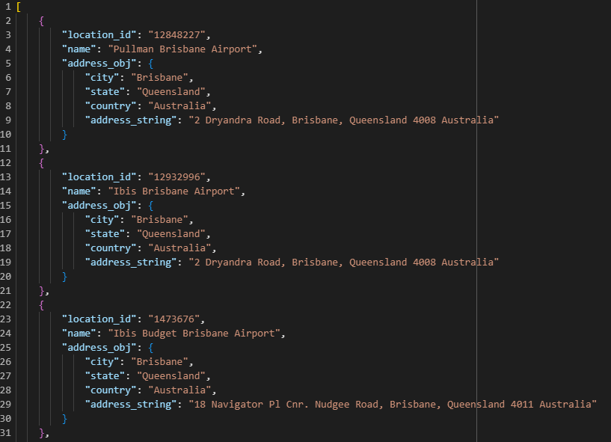

* data/details.csv

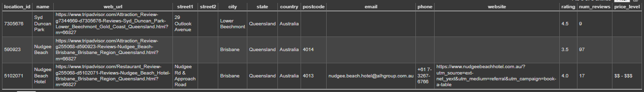

* data/reviews.csv

